The Kite Runner – Vocabulary, Geography, and Other Pertinent Information
Here are some vocabulary words as well as historical, religious, or geographical references in The Kite Runner which you may not already know. I have given you the online citations where I got the information that I used; sometimes I’ve used more than one or added my own notes to explain the current context if necessary. Some of the things I found were whole articles rather than a definition, and sometimes I’ve included a lot of that information. Sometimes in order to get a very succinct definition, I had to resort to using Wikipedia, but I tried to avoid it since it tends to be less reliable than other sources. I tried to find and use sources which could provide an unbiased definition, inasmuch as possible. I have included the page number where the word or phrase first appears in the book – or it might be a later reference if I had missed it earlier! I’ve listed these in alphabetical order.
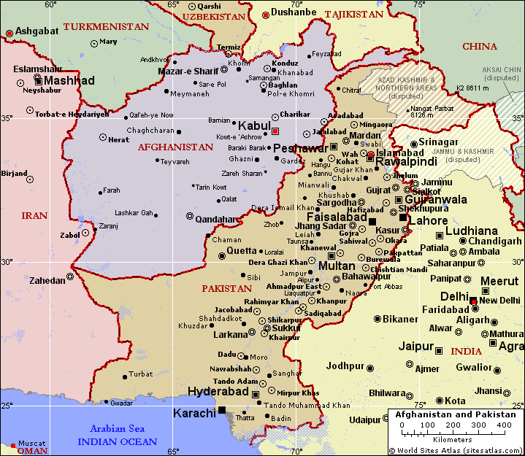
Map: Copyright World Sites Atlas (sitesatlas.com). All rights reserved.
View map legend
“Bamiyan, the city of the giant Buddha statues”; “giant Buddhas in Bamiyan” (Hosseini 337) – two 6th century monumental statues of standing Buddhas carved into the side of a cliff in the Bamyan valley in the Hazarajat region of central Afghanistan. Built in 507 AD, the larger in 554 AD, the statues represented the classic blended style of Gandhara art. . . . They were dynamited and destroyed in March 2001 by the Taliban, on orders from leader Mullah Mohammed Omar, after the Taliban government declared that they were "idols." International opinion strongly condemned the destruction of the Buddhas, which was viewed as an example of the intolerance of the Taliban. Japan and Switzerland, among others, have pledged support for the rebuilding of the statues. (Bing - Wikipedia)
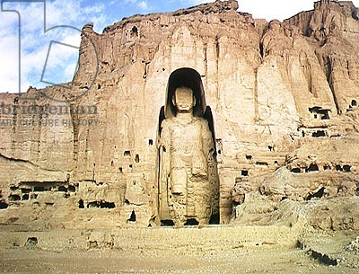
(This photo was taken of one of the statues before the destruction by the Taliban.)
Agha sahib (Hosseini 25) – lord, commander, nobleman, friend, sir (Bing – Foreign terms in The Kite Runner)
Allah-u-akbar (Hosseini 6) – “God is great.”
Bismillah (Hosseini 292) - used by Muslims as a blessing before eating or some other action [shortened from Bismillah-ir-Rahman-ir-Rahim, from Arabic, literally: in the name of God, the merciful and compassionate] (Collins English Dictionary)
Burqa (Hosseini 209) – an enveloping outer garment worn by women in some Islamic traditions to cover their bodies (and faces) in public (Wikipedia)
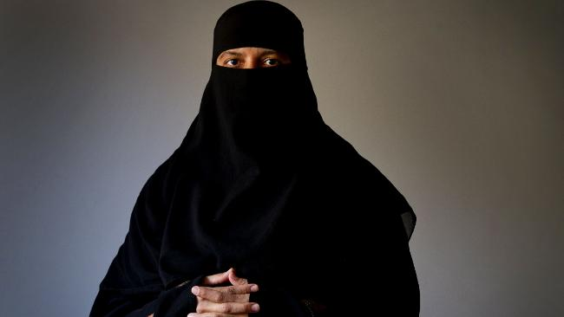
cleft lip (3, 10 Hosseini) – Orofacial clefts are birth defects in which there is an opening in the lip and/or palate (roof of the mouth) that is caused by incomplete development during early fetal formation. (kidshealth.org)
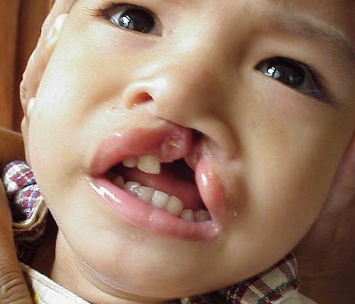
Coup (Hosseini 36) – overturn; upset (merriam-webster.com)
Farsi (Hosseini 15) – the most widely spoken Persian language; the language spoken in Iran (farsinet.com)
Fremont, California (Hosseini 125)
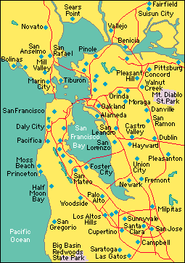
Ghenghis Khan (Hosseini 17) – (1162 – 1227), the founder of the largest contiguous land empire ever established; he united the Mongol tribes and forged a powerful army based on meritocracy, and became one of the most successful military leaders in history. He believed himself commissioned by heaven to establish a world empire. While his image in much of the world is that of a ruthless, bloodthirsty conqueror, Genghis Khan is celebrated as a hero in Mongolia, where he is seen as the father of the Mongol Nation, who brought law, literacy, and learning to his people. . . . In the aftermath of the battles he led, Genghis Khan established an empire that brought peace, stability, and unity to much of central and eastern Asia, and practiced religious tolerance to a remarkable degree at a time when conformity to the doctrines of the established church was rigidly policed in many European countries. . . . The Mongol Empire ended up ruling, or at least briefly conquering, large parts of modern day China, Mongolia, Russia, Ukraine, Korea, Azerbaijan, Armenia, Georgia, Iraq, Iran, Turkey, Kazakhstan, Kyrgyzstan, Uzbekistan, Tajikistan, Afghanistan, Turkmenistan, Moldova, Kuwait, Poland, and Hungary. (newworldencyclopedia.org)
Haddith (Hosseini 324) – a narrative record of the sayings or customs of Muhammad and his companions (merriam-webster.com)
Hazara (Hosseini 7) – The Hazara are a minority, Shia Muslim, Turko-Mongol people, speaking a Persian language, from the high mountains of Central Afghanistan. . . . Their Asian (Mongolian) features immediately distinguish them from other peoples of Afghanistan. The Hazara are visually, linguistically and religiously different from all the other peoples around them. Because of these differences, they have long been despised and persecuted by majority groups. Persecution of the Hazara continues today. . . . While 85% of all Muslims, and virtually all the other major people groups of Afghanistan, are Sunni, the Hazaras are predominantly Shia. . . . Some scholars speculate that the Hazara are descendants of the warriors that flooded into Central Asia under the command of the infamous and brilliant leader, Ghengis Khan. (hazaranet.com)
Henry Kissinger (Hosseini 21) – Henry Alfred Kissinger was the 56th Secretary of State of the United States from 1973 to 1977, continuing to hold the position of Assistant to the President for National Security Affairs which he first assumed in 1969 until 1975. (nobelprize.org)
Hijab (Hosseini 174) – a “hijab” is a veil which covers the hair. It is worn by Muslim women particularly in front of non-related adult males. (Wikipedia.org)
INS (Hosseini 332 and earlier) – US Citizenship and Immigration Services (uscitizenship.info)
Inshallah (Hosseini 33) – “God willing” (merriam-webster.com)
Islam (Hosseini 15) – a religion whose holy book is called the Qur’an. People who follow Islam are called Muslims. Muslims believe that there is only one god, who is called Allah (الله‎, al-lāh) in the Arabic language. Muslims also believe that Muhammad was the last of many prophets from God. They believe that the Qur'an is the exact word of God, as revealed to Muhammad. Muslims also call Muhammad a "messenger of God.” After Muhammad died, Muslims wrote down stories about what he had said and done. Muslims call these stories Hadith. Muslim scholars collected all of these Hadith in books and compared them to each other. They decided which Hadith were most likely to be true records of the Sunnah, that is, the words and actions of Muhammad. Muslims see the Sunnah as an important source of guidance, along with the Qur'an. Islam has rules based on the Qur'an and the Sunnah. These laws are called "Sharia". Muslim lawyers have studied Sharia and written down their ideas about how to judge different cases. These ideas about Sharia are called Fiqh (simple.wikipedia.org).
Islamabad (Hosseini 304) – the capital of Pakistan (wikipedia.org) (See map on page 1.)
Jalalabad (Hosseini 233 and earlier) – a city in eastern Afghanistan (wikipedia.org) (See map on page 1.)
Kabul – the capital and largest city of Afghanistan (wikipedia.org) (See map on page 1.)
Khyber Pass (Hosseini 228) – most northerly and important of the passes between Afghanistan and Pakistan. The pass connects Kābul with Peshāwar. The pass has historically been the gateway for invasions of the Indian subcontinent from the northwest. (britannica.com)
King Mohammad Nadir Shah (Hosseini 5) – Mohammad Nadir was the king of Afghanistan from 1929 until he was assassinated in 1933. Before seizing the throne, Mohammad Nadir played a major role in the third Anglo-Afghan War (1919). Soon after that, because of disagreements with King Amanullah, Mohammad Nadir left Afghanistan to live in exile in France. After Habibullah Kalakani's rebellion and the abdication of King Amanullah (January 1929), Nadir left France and headed for India to prepare for his war against Kalakani. With British and various tribal support from India, Mohammad Nadir pushed back Kalakani and captured Kabul in October 1929. He later tricked Kalakani into believing he would not be killed, then captured him, and hanged him and many of his followers. After becoming king, Mohammad Nadir fought hard against people who wanted to restore King Amanullah to the throne. He also reversed many of the modernization plans set forth by King Amanullah, and favored up to various religious extremists. Mir Ghulam Mohammad Ghobar, one of Afghanistan's most respected historians, describes Mohammad Nadir's rule as tyrannical. Nadir pinned ethnic groups against one another, (Tajiks and Pashtuns), raped, destroyed, and pillaged the Shamali area to the north of Kabul. Mohammad Nadir Shah was born in 1883. (afghan-web.com/bios)
Koran (Hosseini 15) – the sacred text of Islam, divided into 114 chapters, or suras: revered as the word of God, dictated to Muhammad by the archangel Gabriel, and accepted as the foundation of Islamic law, religion, cultures, and politics (dictionary.reference.com)
Mujahedin (Hosseini 212 and earlier) – (plural noun- sometimes initial capital letter) Muslim guerilla fighters, especially in Afghanistan and Iran (dictionary.reference.com) (My note: This is a difficult term to define due to the far-reaching political consequences of actions by the Mujahedin, historically and currently. For example, during the Cold War, the United States covertly armed the Mujahedin in Afghanistan to help them defeat the Russians; a great movie on this “war” is Charlie Wilson’s War with Tom Hanks and Julia Roberts if you’re interested. Unfortunately, however, when the US invaded Afghanistan after 9/11, those same arms were used – are being used – against the US. Also, now the Mujahedin and the Taliban are so closely connected that the Mujahedin, like the Taliban, are often considered to be terrorists.)
Namaz (Hosseini 364 and earlier) – Sunni Muslim prayers five times a day: morning, early afternoon, late afternoon, evening, and at night (www.hizmetbooks.org). Shi’a Muslims pray three times a day.
Pakol (Hosseini 230) – a soft, round-topped hat made of 100% camel or sheep wool worn by people in Afghanistan, the North West Frontier of Pakistan and other areas in the region. It fits the wearer’s head. (southpacfticberets.com)
Pashtun (Hosseini 9) - also spelled Pushtun, or Pakhtun, Hindustani Pathan, Persian Afghan, Pashto-speaking people of southeastern Afghanistan and northwestern Pakistan. They constitute the majority of the population of Afghanistan and bore the exclusive name of Afghan before that name came to denote any native of the present land area of Afghanistan. The origins of the Pashtun are unclear. Pashtun tradition asserts that they are descended from Afghana, grandson of King Saul of Israel, though most scholars believe it more likely that they arose from an intermingling of ancient Aryans from the north or west with subsequent invaders. Several Pashtun tribes are known to have moved from Afghanistan to Pakistan between the 13th and 16th century. Each tribe, consisting of kinsmen who trace descent in the male bloodline from a common tribal ancestor, is divided into clans, subclans, and patriarchal families. . . There are estimated to be about 7,500,000 Pashtun in Afghanistan and 14,000,000 in Pakistan (britannica.com).
Persian (Hosseini 351) – old alternate name for the Asian country Iran (encyclopedia.com).
Peshawar – a frontier town in Pakistan new the Khyber Pass (travel.org) (See map on page 1.)
Ramadan - Ramadan is the ninth month of the Islamic lunar calendar, and is the month of fasting for observant Muslims. Because the cycle of the lunar calendar does not match the solar calendar, the dates of Ramadan shift slightly each year. The origins of Ramadan draw significantly from the occasion of Laylat al-Qadr, frequently translated as "the Night of Power." It was on this night in 610 C.E., that Muslims believe the Quran was first revealed to the Prophet Muhammad and led the entire month to be seen as a holy time in the calendar. During the month of Ramadan, adult Muslims engage in ritual fasting from sunup to sundown. This practice, Sawm, is one of the five pillars of Islam, and requires that individuals abstain from eating, drinking, smoking and sexual intercourse. Each evening, Muslims will break the fast at sundown with Iftar, a traditional meal often beginning with the eating of dates – an homage to a practice of Muhammad. (huffingtonpost.com)
Salaam Alaykum (Hosseini 234 and earlier) – (Arabic; As-salamu Alaykum) “peace be to you” – a traditional greeting among Muslims (merriam-webster.com)
Shahnamah (Hosseini 29) – Among the great works of world literature, perhaps one of the least familiar to English readers is the Shahnameh: The Persian Book of Kings, the national epic of Persia. This prodigious narrative, composed by the poet Ferdowsi between the years 980 and 1010, tells the story of pre-Islamic Iran, beginning in the mythic time of Creation and continuing forward to the Arab invasion in the seventh century. As a window on the world, Shahnameh belongs in the company of such literary masterpieces as Dante’s Divine Comedy, the plays of Shakespeare, the epics of Homer— classics whose reach and range bring whole cultures into view. In its pages are unforgettable moments of national triumph and failure, human courage and cruelty, blissful love and bitter grief. In tracing the roots of Iran, Shahnameh initially draws on the depths of legend and then carries its story into historical times, when ancient Persia was swept into an expanding Islamic empire. (amazon.com)
Shalwar-kameez (Hosseini 327 and earlier) – (also spelled salwar kameez or shalwar qameez) is a traditional dress worn by both women and men in South Asia and Central Asia. Shalwar or salwar are loose pajama-like trousers. The legs are wide at the top, and narrow at the ankle. The kameez is a long shirt or tunic. The side seams (known as the chaak), left open below the waist-line, give the wearer greater freedom of movement. It is notably known for being the national dress of Pakistan. (wikipedia.org)
Shari’a (Hosseini 230) – the code of law based on the Koran (the freedictionary.com) (My Note: Again, this term is ambiguous and controversial because of all of the ways that the “law based on the Koran” can be interpreted. The connotation which it often carries today is of harsh and violent punishments for any infraction of laws, rules, and customs which some Muslims interpret as being in the Koran – for example, being stoned to death for committing adultery, having hot oil poured into the face of a female accused of any sexual indiscretion – even if she had been raped. However, not all Muslims interpret Shari’a that harshly.)
Shi’a (Hosseini 8) – (also called Shi'ites) "Party" of 'Ali. The Shiites believe that Mohammad designated his son-in-law, 'Ali, to succeed him as leader of the umma of Islam. Members of Shiite communities (which often vary from each other on important issues) number about 10-15% of the total Muslim community today. 'Ali b Abi Talib formed Shiat 'Ali (Party of 'Ali) believing that Mohammad had appointed 'Ali as his successor. Others did not believe this. (answers.com)
The term Shi'a is Arabic for “group” or “action.” It is applied to those who believe that, after the death of the Prophet, the Imamate (the political and religious leadership of the Muslim community) should have gone to 'Ali - the cousin and son-in-law of the prophet - and his descendants as a divine right. The three caliphs who preceded 'Ali - Abu Bakr, 'Umar, and 'Uthman - were not intended by Muhammad to be his immediate successors. The Imam is regarded by Shi'ites not merely as a political leader but as a metaphysical being, one who is without sin, whose doctrinal pronouncements are infallible and who bestows true knowledge on humanity. The Imams are referred to within the Shi'ite tradition as masum - free from error or sin - and are regarded by the majority of Shi'as as twelve in number. The last Imam, the Mahdi, is believed not to have died but to be in hiding and will appear at the end of time in order to bring about the victory of the Shi'a faith. Unlike the Sunnis, who perform prayers five times a day, the Shi'ites pray three times a day: in the morning, in the afternoon, and at night. Like other Muslims, they perform ritual ablutions before prayer. However, they customarily place a tiny tablet of clay brought from a holy place on the spot where their forehead will touch the ground. (philtar.ac.uk/encyclopedia/islam/shia).
Shorawi (Hosseini 246 and earlier) – The Farsi term for the Soviets, who invaded Afghanistan in 1979 and occupied the country for a decade. (shelfari.com/glossary/Shorawi)
Sufism (Hosseini 249) – Sufism (from Arabic (صوف), Suf meaning "wool") is a mystical tradition of Islam dedicated to experiencing Allah/God as the epitome of divine Love. Sufis can be associated with Shi'a Islam, Sunni Islam, other currents of Islam, or a combination of multiple traditions. . . .Sufis believe that excessive rationalism blocks human understanding of God's immersive and loving nature. Consequently, they focus on directly experiencing God through ecstatic practice in order to efface the obstructing self. Sufis have endured persecution over the years due to their unconventional and controversial approach to Allah, which has been perceived by some to be blasphemous. (newworldencyclopedia.org)
Sunni (Hosseini 9) - Sunni Islam
"Islam" comes from the Arabic word meaning “peace” and “submission.” For Muslims around the world it is a way of life requiring absolute submission to the will of God. Islam dates from 622 C.E. and is based on the prophetic revelations of Muhammad. From its Middle Eastern roots Islam has spread around the world and, with over a billion followers, is the second largest of the world's religions, after Christianity. . . . Although they accept the divine status of the Jewish and Christian revelations, Muslims believe that Muhammad was the "Seal of the Prophets," the last of God's messengers. The word of God as revealed to Muhammad is recorded in the Holy Qurʾan, the infallible guide to Muslim conduct. Further guidance is provided by the sunna, the authoritative example of the Prophet, whose words and deeds are recorded in the hadith (literally “tiding” or “information”; more broadly “every word, deed, and approval attributed to Muhammad”). "Sunni," derived from "sunna," describes allegiance to the ways of the Prophet. Within the Sunni tradition there are four schools of jurisprudence (Hanifis, Malikis, Shafis, Hanbalis) that differ in their interpretations and applications of religious law, including some minor issues related to food (encyclopedia.com).
Taliban (Hosseini 198) – The Taliban, an Islamic extremist group, took control of Afghanistan's government in 1996 and ruled until the 2001 U.S.-led invasion drove it from power. The group is known for having provided safe haven to al-Qaeda and its erstwhile leader Osama bin Laden, as well as for its rigid interpretation of Islamic law, under which it publicly executed criminals and outlawed the education of women. Though the group has been out of power for several years, it remains resilient in the region and operates parallel governance structures aimed at undermining the U.S.-backed central government. Pakistan's support and safe havens for the Taliban have stymied international efforts to end the insurgency in Afghanistan; the United States is set to withdraw its combat forces from the country by 2014. Since 2010, both U.S. and Afghan officials have been pursuing talks with members of the group for a negotiated settlement to the conflict in Afghanistan. But prospects for such a settlement remain uncertain and have raised concerns among Afghanistan's minorities and women who worry their rights and freedoms may be compromised.
The Taliban was initially a mixture of mujahadeen who fought against the Soviet invasion in the 1980s, and a group of Pashtun tribesmen who spent time in Pakistani religious schools, or madrassas, and received assistance from Pakistan's Inter-Services Intelligence agency (ISI). The group's leaders practiced Wahhabism, an orthodox form of Sunni Islam similar to that practiced in Saudi Arabia. With the help of government defections, the Taliban emerged as a force in Afghan politics in 1994 in the midst of a civil war between forces in northern and southern Afghanistan. They gained an initial territorial foothold in the southern city of Kandahar, and over the next two years expanded their influence through a mixture of force, negotiation, and payoffs. In 1996, the Taliban captured capital Kabul and took control of the national government. Taliban rule was characterized by a strict form of Islamic law, requiring women to wear head-to-toe veils, banning television, and jailing men whose beards were deemed too short. One act in particular, the destruction of the giant Buddha statues in Bamiyan, seemed to symbolize the intolerance of the regime. The feared Ministry for the Promotion of Virtue and Prevention of Vice authorized the use of force to uphold bans on un-Islamic activities. Before its ouster by U.S.-led forces in 2001, the Taliban controlled some 90 percent of Afghanistan's territory, although it was never officially recognized by the United Nations. After its toppling, the Taliban has proved resilient. In June 2011, the International Crisis Group reported that the Taliban had expanded far beyond its stronghold in the south and southeast to central-eastern provinces. "Insurgent leaders have achieved momentum in the central-eastern provinces by employing a strategy that combines the installation of shadow governments, intimidation, and the co-opting of government officials," it noted.
While a surge in U.S. troops in 2010 and improved capacity of the Afghan security forces has put increasing pressure on the Taliban, in March 2011, the U.S. military viewed the security gains achieved in the last year as "fragile and reversible." A February 2011 report from the London-based International Council on Security and Development (ICOS) noted that insurgents are adapting their tactics. "Insurgents are now avoiding firefights and direct attacks on NATO-ISAF/Afghan positions, and are focusing on using roadside bombs and targeted killings instead," the report says. Assassinations of high-level Afghan officials, experts say, are designed to intimidate Afghan civilians and erode public confidence in their security forces. In its report to Congress in September 2011, the White House cited polls showing only 33 percent of the Afghan population considered security in their communities to be good, compared to 50 percent in June 2010. "This change," it noted, "appears to affirm the effectiveness of the insurgents' strategy of perception-oriented targeting" (cfr.org/afghanistan) (Council on Foreign Relations).
Tashakor (Hosseini 228) – “thanks”

